Audio and Electroacoustics
Design and Implementation
of Signal Processing Systems
Image and Multidimensional Signal Processing
Multimedia Signal Processing
Signal Detection and Estimation
Sensor Array and Multichannel Processing
Signal Processing for Communications

Speech Processing
Education in Signal Processing
Nonlinear Signal Processing
Medical Imaging and Image Analysis
Signal Processing Applications (Biology, Geophysics, Seismic,
Radar, Sonar, Remote Sensing, Astronomy, Bio-informatics,
Positioning etc.)
Emerging Technologies
CALL FOR PAPERS

The 2006 European Signal Processing Conference (EUSIPCO-2006) is the fourteenth in a series of conferences promoted by EURASIP, the European Association for Signal, Speech, and Image Processing (www.eurasip.org). Formerly biannual, this conference turns for the second time into a yearly event. This edition will be organized by the University of Pisa in the Palazzo dei Congressi, at the very heart of Florence, the capital of Italian Renaissance.

EUSIPCO-2006 will focus on the key aspects of signal processing theory and applications as listed below. Exploration of new avenues and methodologies of signal processing will also be encouraged. Accepted papers will be published in the Proceedings of EUSIPCO-2006. Acceptance will be based on quality, relevance and originality. Proposals for special sessions and tutorials are also invited.

Areas of Interest

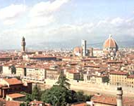
14th European Signal Processing Conference
EUSIPCO 2006
September 4-8, 2006, Florence, Italy

European Association
for Signal, Speech and Image Processing

General Chairman

M. Luise, University of Pisa, Italy
m.luise@iet.unipi.it

Technical Program Co-Chairmen

F. Gini, University of Pisa, Italy
f.gini@iet.unipi.it

E.E. Kuruoğlu, CNR, Pisa, Italy
kuruoglu@isti.cnr.it

Special Sessions and

Plenary Talks

G. Sicuranza, Univ. of Trieste, Italy
sicuranz@univ.trieste.it

H. Bölcskei, ETH Zürich, Switzerland
boelcskei@nari.ee.ethz.ch

Tutorials

A. Gershman, Darmstadt University of
Technology, Germany
gershman@nt.tu-darmstadt.de

Publications

M.S. Greco, University of Pisa, Italy
m.greco@iet.unipi.it

L. Fanucci, University of Pisa, Italy
l.fanucci@iet.unipi.it

Local Arrangements

F. Giannetti, University of Pisa, Italy
f.giannetti@iet.unipi.it

M. Morelli, University of Pisa, Italy
m.morelli@iet.unipi.it

Publicity

G.T. Zhou, Georgia Tech, USA
gtz@ece.gatech.edu

R. Fantacci, University of Florence, Italy
fantacci@lenst.det.unifi.it

Overseas Liaisons

G.B. Giannakis, Univ. of Minnesota, USA
georgios@ece.umn.edu

U.B. Desai, Indian Inst. of Tech., India
ubdesai@ee.iitb.ac.in

K.V.S. Hari, Indian Inst. of Science., India
hari@ece.iisc.ernet.in

X. Liu, Shanghai Jiaotong University, China
xzhliu@sjtu.edu.cn

Exhibits & Awards

F. Berizzi, University of Pisa, Italy
f.berizzi@iet.unipi.it

Secretariat and Registration
 | D.G.M.P. srl  info@dgmpincor.it  tel. +39 050 879740  fax +39 050 879812

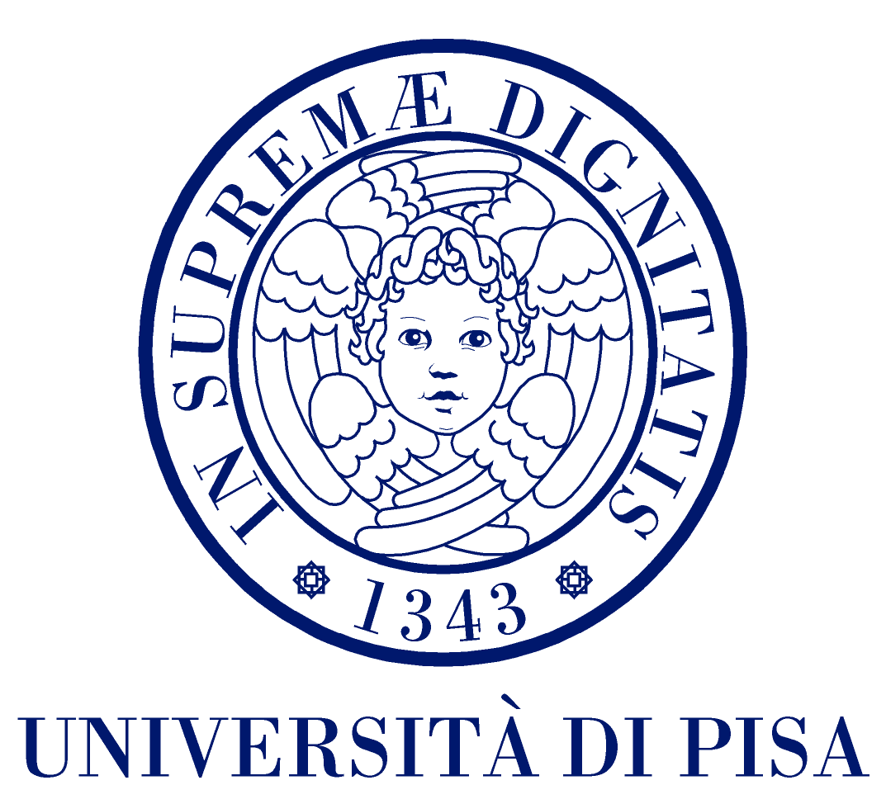


Best Student Paper Awards
There will be a student paper contest. Student authors who appear as first authors in a paper may enter the student paper contest.
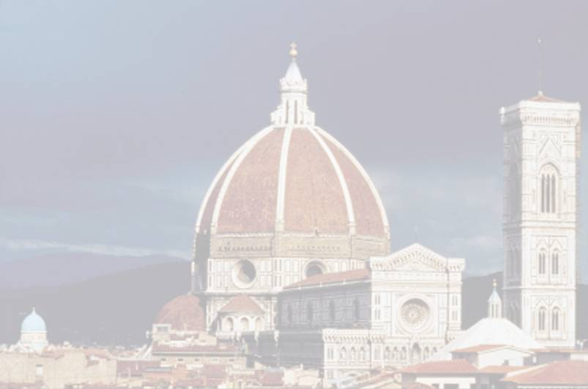

Submission
Procedures to submit a paper, proposals for special sessions/tutorials, can be found at www.eusipco2006.org. Submitted papers must be camera-ready, final, no more than five pages long all inclusive and conforming to the format specified on the EUSIPCO web-site above.

Important Dates

Proposals for Special Sessions and Tutorials: December 02, 2005
Submission of Full papers: January 20, 2006
Notification of Acceptance: April 07, 2006
Submission of Camera-Ready Papers and Registration: May 05, 2006

www.eusipco2006.org

