SOCIAL PROGRAM FORM

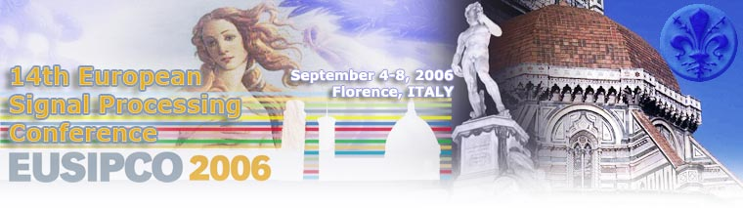

Please return this form by fax to the Organizing Secretariat:
 D.G.M.P. srl
Via di Scornigiana trav. B - 56121 Opsdaletto - Pisa, Italy
Ph. +39 050 989310 – Fax. +39 050 981264
e-mail: info@dgmpincor.it

Last Name First Name
Affiliation
Address
Zip code City Country
Ph. Fax E-mail
I’m the accompanying person of:

WELCOME COKTAIL:

Additional welcome cocktail n°______ x 20,00 Euro Tot. ___________

BANQUET:

Sept. 7th Gala Dinner at Grand Hotel n° _____ x 70,00 Euro Tot. ____________

TOURS:

Sept. 5th Siena and San Gimignano (full day) n° _____ x 80,00 Euro Tot. _____________
Sept. 6 th Lucca e Pisa (full day) n° _____ x 75,00 Euro Tot. _____________
Sept. 7th Florence (half day, walking) n° _____ x 20,00 Euro Tot. _____________

TOTAL AMOUNT DUE Euro Tot. _____________

PAYMENT:

❑ by cheque n° ________________________ to the order of D.G.M.P. of the bank __________________herewith enclosed

by Credit Card: VISA  MASTERCARD  DINERS

Credit card N° |__|__|__|__|__|__|__|__|__|__|__|__|__|__|__|__| Expiration date: Month_____ Year ____

Name (in block letters) as it appears on card ___________________________________
I authorise the use of my card for this purpose. Please pay attention that D.G.M.P. will appear on your credit card charges notes.

Date___________________ Signature __________________________

